

**COMSATS University Islamabad**

**Subject Name:**

CSC103-Programming Fundamentals

**FINAL LAB PROJECT**

**QUESTION BANK AND QUIZ MANAGEMENT SYSTEM**

**Submitted by:**

Hafif Ashiq SP21-BCS-023

Abdullah Haroon SP21-BCS-001

Laiba Adnan SP21-BCS-036

Hisham Bin Mukhtar SP21-BCS-029

**Submitted to:**

Sir Rizwan Rashid

**Date of Submission:**

12/01/2022

Table of Contents

**INTRODUCTION1**

**TASK DISTRIBUTION**

Question Bank and Quiz Management System 3

1. Introduction: 3

2. Task Distribution: 3

3. Features of Program: 3

4. Modules used in Program 4

i. Login 4

ii. Question Bank Modification 4

iii. Quiz Attemption 5

iv. Generation of Terminal Examination 5

v. Profile Management 5

vi. Administration Control 6

# Question Bank and Quiz Management System

## Introduction:

This project is about a question bank and quiz management system. As the name suggests that it consist of two different types of similar projects adjoining them into one single program for the ease of the users using it to keep the record. The program reflects the modern-day techniques for educational institutions and helps the users to generate quiz questions and examination paper from the previously existing upgradeable question bank. The question bank is held separate for all different type of questions and thus each one can be separately updated by the user. Moreover, the program can be logged in via three types of users with the access to specific roles designed for each of the user. For Instance, the student can only see his profile and attempt quiz whereas the admin of the system has the access to almost every functionality of the program as he is the one to control everything. The Examination paper generated is saved in for of .txt file that can be printed afterwards.

## Task Distribution:

Task completed by each team members are as follows:

* **Abdullah Haroon** was responsible for the creation of login system for users along with quiz questions management and the field validation of the program.
* **Hisham Bin Mukhtar** did the functionality of Question Bank modification and the profile management of students.
* **Laiba Adnan** made the design and layout for the menus of system as well as Terminal Paper generation as well as quiz Attemption by the Student.
* **Hafif Ashiq** was assigned the work of administration control including viewing students and teachers record, addition of users, viewing questions in question bank etc.

## Features of Program:

* Password Protected at student as well as teacher’s end
* Use of Modules to make the main program shorter and easier to understand
* Storing all information in form of .txt files to access data if the program is rerun after closing.
* Implementation of Field Validation using exceptional handling to secure program from crashing in any scenario possible.
* Calculates average of the all quizzes attempted by the student.
* Adds the facility to add or modify or remove any question in the database.
* Updates the database after every task including modification and deletion of the files.
* Addition of any individual is easy and user friendly.
* Every module has a specific function and task to be performed.

## Modules used in Program

The Program uses modules to make main program shorter and easier to understand. Each module has a function of its own which is called upon whenever necessary. They are as follows:

### Login

The emails, designations and passwords of users are stored in separate files. One file containing only emails, second having passwords and third with the designations i.e., Student, Teacher or Admin. The Teacher also has the subject of interest with it that he/she teaches. The module fetches the email entered by the user, checks if it is present in file. If present, it checks whether the login designation matches the one corresponding with email and if it matches, the password is checked. After all the processes completed, the module returns an integer, each representing a specific designation. If the designation matches the user’s login criteria, user moves to next menu, else an appropriate message is shown.

### Question Bank Modification

The Question Bank Modification is divided into parts as follows:

#### **Addition of Quiz Questions**

The Quiz Questions can be added to the Question bank by the teacher only and is specified by the path. The questions and options are saved in a text file in a separate folder along with the answers to those questions as well. The teacher is asked to enter a question and then its options and answers which are then saved in file retaining the previous questions in the file.

#### **View and Modification of Quiz Questions**

The Quiz questions can be modified individually. When the teacher wishes to update or remove a Multiple-Choice Question, he can select the option from menu to do so. After selection, teacher will be shown the MCQs regarding his subject and will be asked the serial number if he wants to modify the question. After selection of question, he is asked to either replace the entire question or update the question relating to the options or the answer of the question. The teacher will also be given the option to delete the question as well.

#### **Addition of Exam Questions**

In this module, the teacher can add the questions of True/False, Short Questions and Long Questions that will be required to generate the terminal exam for the students. The teacher is required to enter the questions regarding the option and after that the file containing questions will be updated.

#### **View or Delete Exam Questions**

The teacher can view all the questions in the database i.e., text file, and which all questions will be displayed on the screen and if he wishes to delete any question, he can do so after which file will be updated.

### Quiz Attemption

The student when logged in, can attempt the quiz of the subject he chooses. The quiz will be generated by choosing random questions from the question bank and multiple options will be displayed to choose from. The answer will be matched with the answer entered by the teacher while adding the question and scores will be updated accordingly. The student can score up-to 15 in any quiz as of 15 questions given and the final marks will be updated in the information.

### Generation of Terminal Examination

The terminal exam can be generated by the teacher. For this purpose, teacher is required to enter the number of True/False, Short and Long Questions in the Exam along-with its marks. The total marks will be calculated and should be equal to 100, else the teacher has to give the correct inputs again.

After all the values are given, the paper will be generated and stored in a file with year number as entered by the teacher. The teacher can view the paper once after formation but changes in question paper are not allowed as it is randomly generated by the system from the database of questions.

### Profile Management

The profile management module is divided as:

#### **Student Profile Management**

The profile of all students can be accessed by admin as well as teacher in which the file of information is read and displays all information in tabular form. The user can also see the profile of the specific student if he chooses so, in which case the teacher gets the serial number of the student and fetches the information related to the student and displays it.

Every student can see his or her respective information once logged in displaying his basic information.

#### **Teacher Profile Management**

The profile of teachers can only be accessed by the admin containing basic information and the subject of the teacher.

### Administration Control

The administration control is divided into following modules:

#### **Add Student or Teacher Record**

The admin can add teacher or student record. Once opted for this, the user will enter all the required information of student or teacher creating an account protected by password created by the user. The information will then be saved in the respective files and the files will be updated.

#### **Edit Profile**

The profiles of students once created can be edited if the information entered is to be updated or is incorrect. The user will be asked the type of information and the updated information to complete the process which will be updated in the respective files after completion.

#### **View Quiz or Exam Questions**

The admin of the system can view all the questions for quiz and examination if he wishes so. To do so, he will be required to enter the serial number of subject and the questions will be displayed.

#### **View Terminal Examinations**

The terminal examinations of all subjects are present in separate directory which can be accessed by admin. The admin will be displayed the list of all the examinations listed and can be opened by listing the serial number of the exams shown. After entering the number, the exam will be shown to the user.

## Outputs

**Login:**

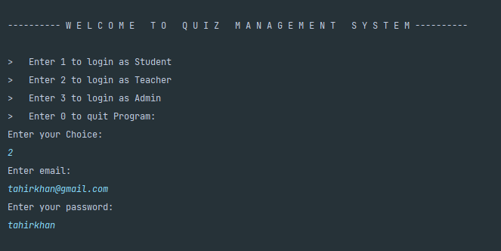

**Add Quiz Questions:** 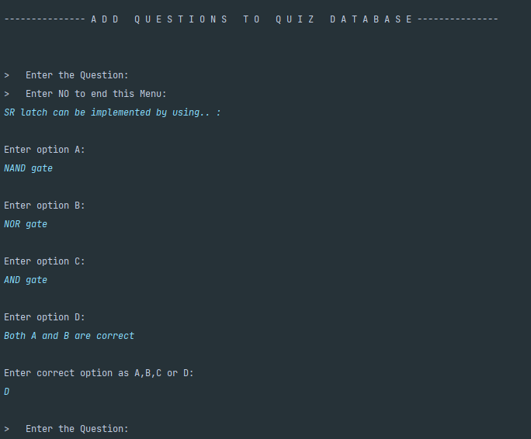

**View or Modify Quiz Questions**

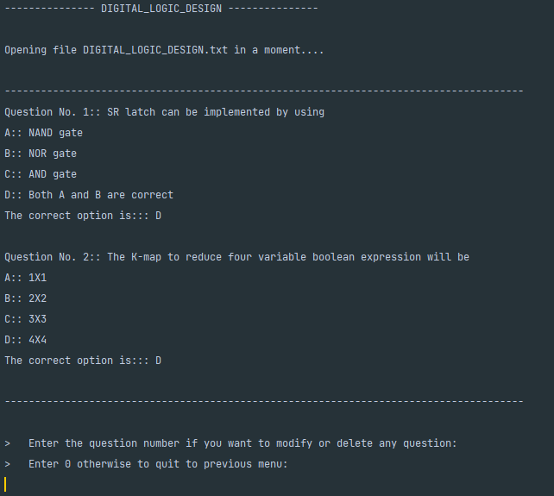

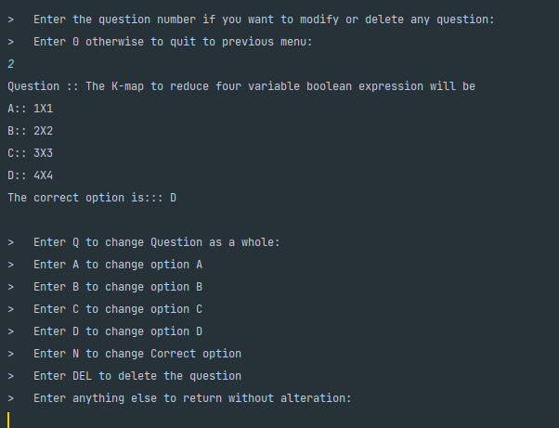

**View Quiz Questions**

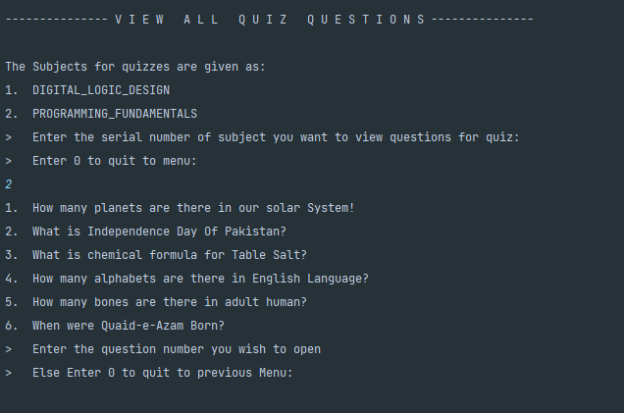

**Add Exam Questions**

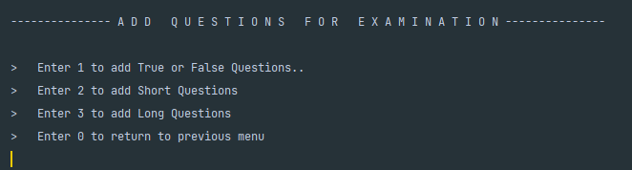

**View Exam Questions**

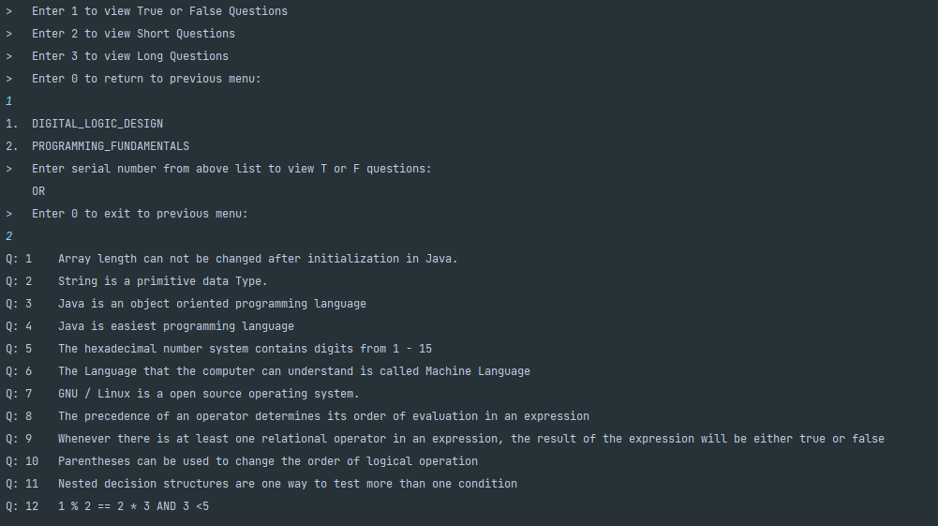

**View Terminal Exams**

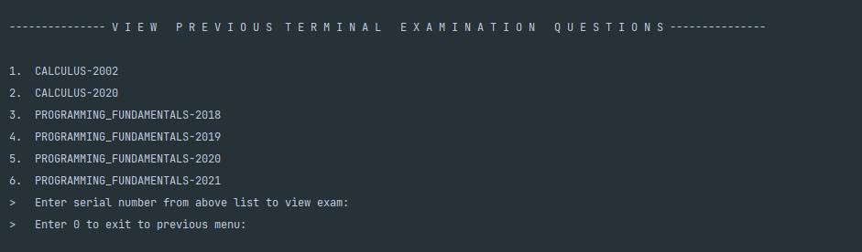

**Terminal Paper Generation**